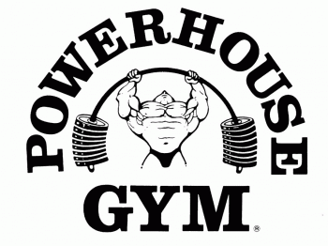

2023 Class Schedule – Yoga, Zumba, and Circuit Training classes are FREE with any membership

Monday Tuesday Wednesday Thursday Friday Saturday Sunday
Brad Debbie Debbie Debbie
Circuit Training Circuit Training Circuit Training Circuit Training
8:15am 8:15am 8:15am 8:00am

Megan
Zumba Class
9:00am

Amanda
$ Boot Camp $
9:30am

Mary Beth Matt
Yoga Class Boxing Class
10:00am 10:30am

Mary Beth Debbie Melanie
Yoga Class Circuit Training Yoga Class
6:00pm 6:00pm 6:00pm

Lisa Megan Megan
$ Muscle Madness $ Zumba Class Zumba Class
6:30pm 7:30 pm 7:30pm

